How to Quick Import into Microsoft Forms
- Cut and paste the questions from ChatGPT to Microsoft Word, retaining only the questions and deleting the header and footer information
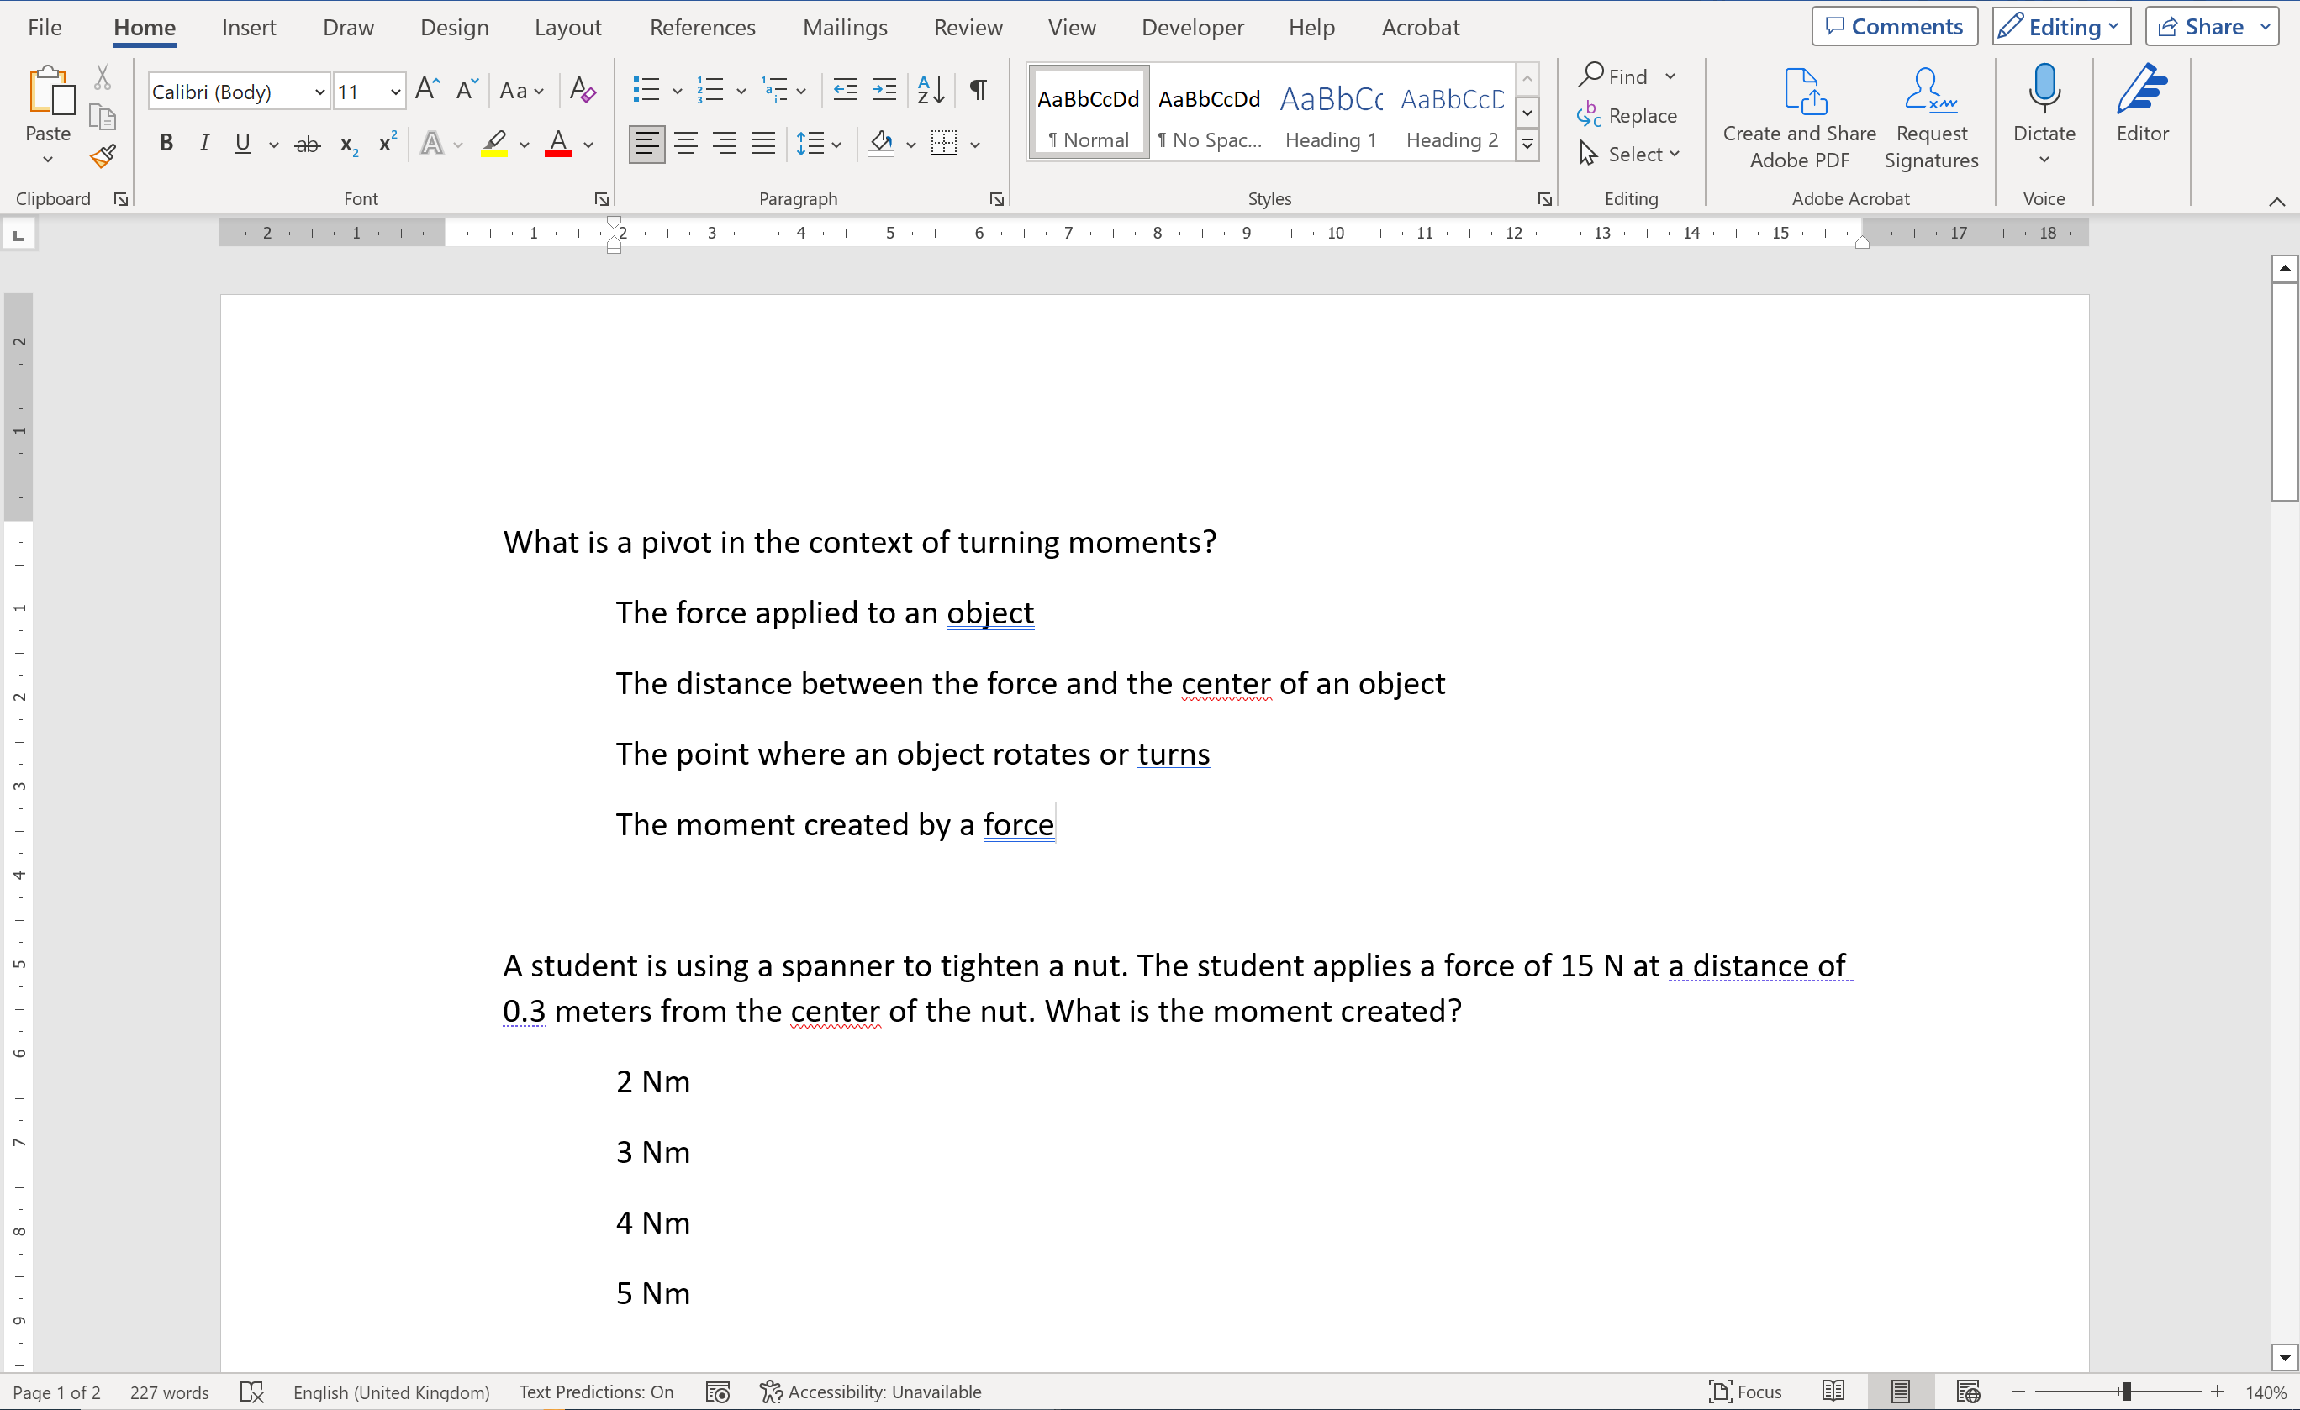
- In Word, select all of the content (ctrl-A) and press the “Multilevel list” button in the “Paragraph” menu. This will change the questions insofar as giving the questions question numbers (e.g., 1, 2, 3, …) and giving the answer options nested numbers (e.g., 1a, 1b, 1c, …)
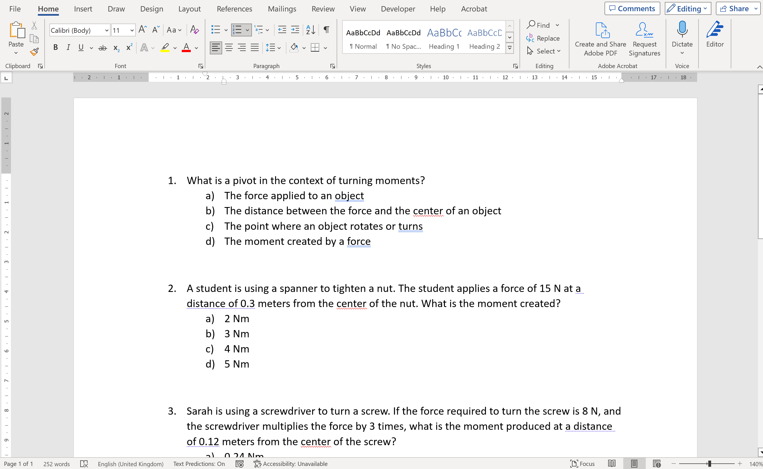
- Save the file

- Navigate in a web browser to Microsoft Forms (note, do not use the version provided by Sharepoint, if your school has such a thing, because we are going to use an option only available in the online version; the online version should accept the same log in information as your Sharepoint version)

- In Forms, select the option “Quick import” (this is not available in the Sharepoint version of Forms)
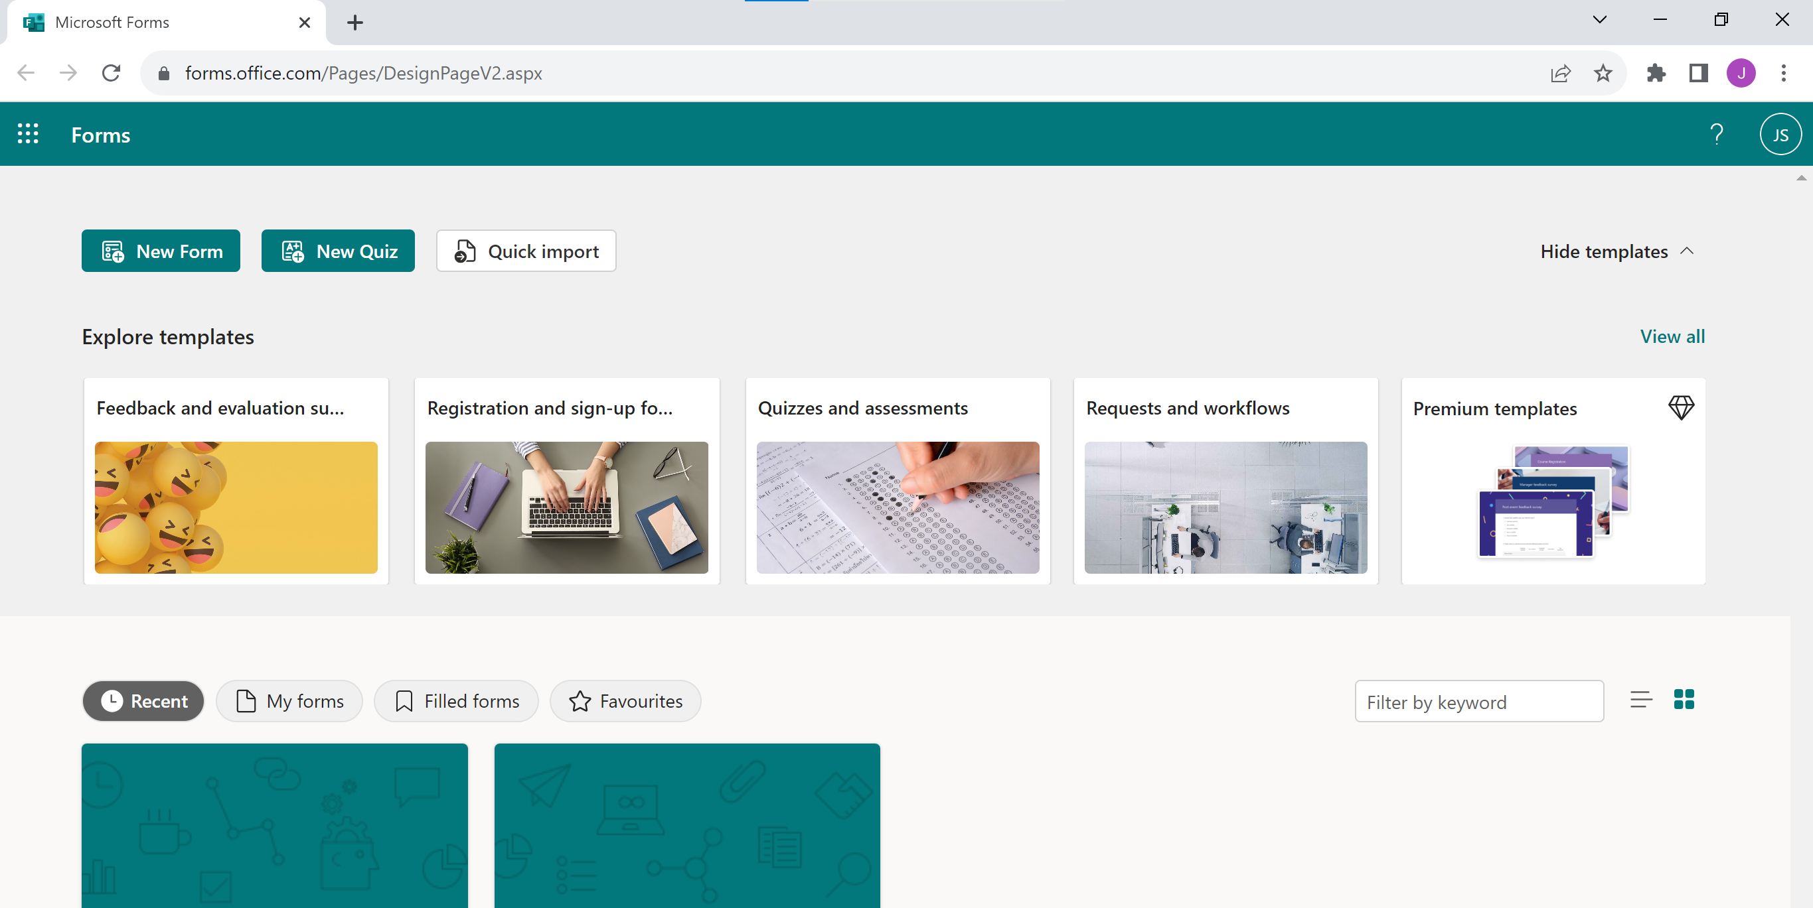
- Select “Upload from this device” and choose the Word file that you saved earlier
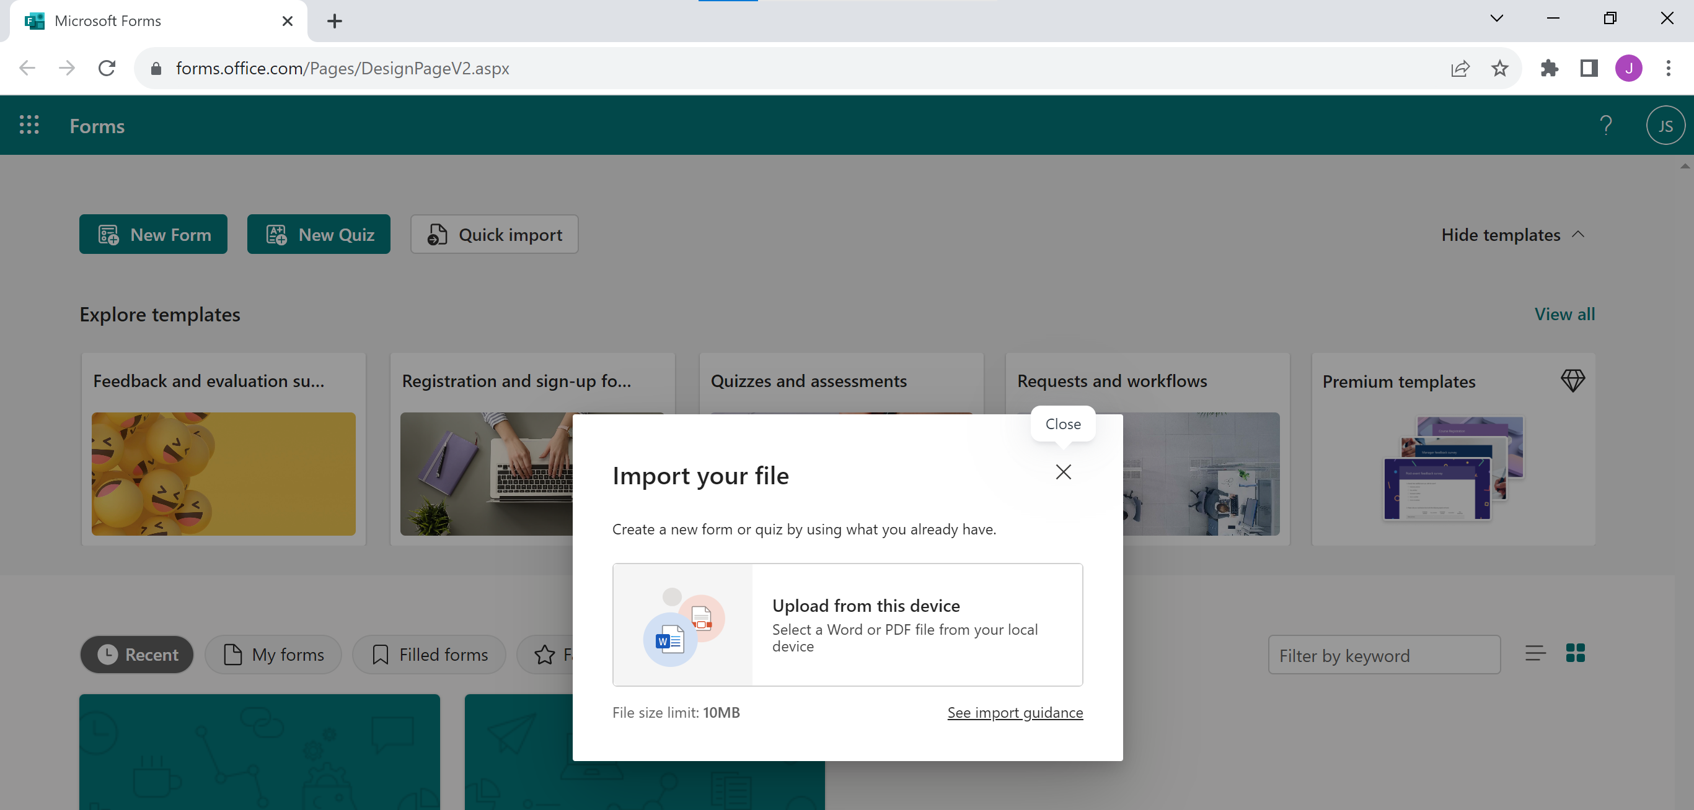
- Select the option “Quiz”
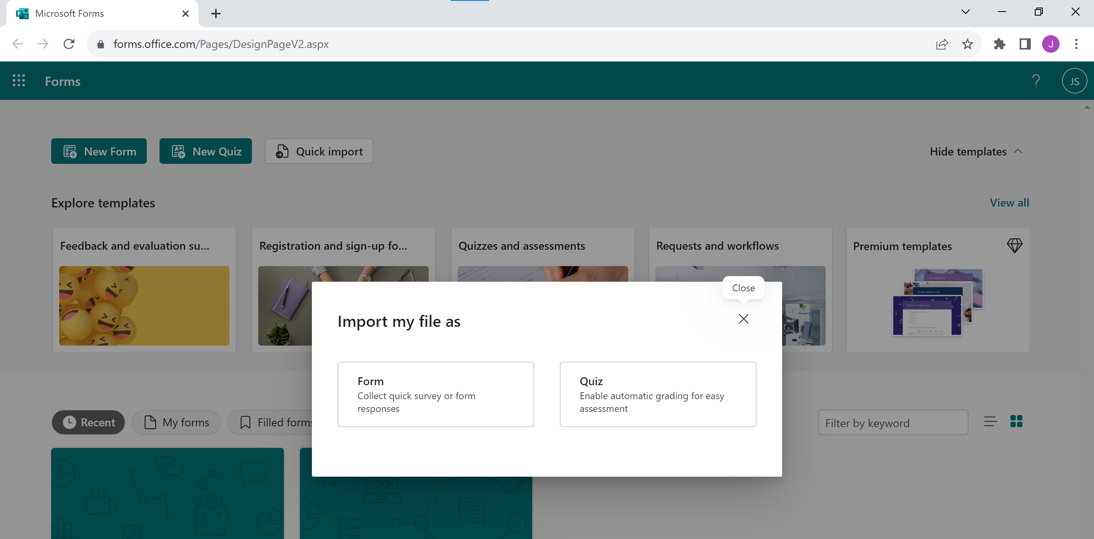
- Select the option “Start review”, proofread all questions, select the correct answers so Forms can grade pupils, and define points if you want to
