Stellar evolution: Energy stores & transfers

The different stages of stellar evolution can be understood in terms of the energy stores and transfers that are predominant. Remember:
Stores | Transfers
Chemical  Kinetic  Gravitational potential  Electrostatic  Thermal  Magnetic  Elastic potential  Nuclear | Heating  Electrical  Radiation  Mechanical

For the following stages of stellar evolution, identify the principal energy stores and transfers (the first has been done for you):
- A Nebula
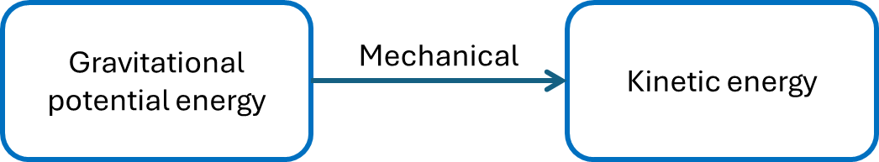
- A Protostar
- A Star (main sequence) or a Red Giant

- A White Dwarf

